**CSCI992-USER'S MANUAL**

**Group B**

|  |
| --- |
| https://encrypted-tbn0.gstatic.com/images?q=tbn:ANd9GcTfqK2kTp3Juk04CdltLH0DjnHT1ayBzFoENEYccn-p-kcyfgL8 **School of Computer Science** |

**Contents**

A. GENERAL INFORMATION 1

1.1 System Overview 1

1.2 Authorized Use Permission 2

1.3 Points of Contact 2

1.3.1 Information 2

1.3.2 Help Desk 2

1.4 Organization of the Manual 2

B. SYSTEM SUMMARY 3

2.1 System Configuration 3

2.2 Data Flows 4

2.3 User Access Levels 4

C. GETTING STARTED 5

3.1 Register to system 5

3.2 Logging On 7

3.3 Menu Bar 9

3.3.1 Search bar 9

3.3.2 Check cart 9

3.3.3 Home page 10

3.3.4 Recommendation 10

3.3.5 Services 11

3.3.6 Discount 14

3.3.7 First time user 14

3.3.8 My services 15

3.3.9 Member Center 15

3.4 Exit 20

3.4.1 Logout and exit 20

3.4.2 Default exit 20

3.5 Special instructions for error correction 21

# GENERAL INFORMATION

## 1.1 System Overview

Service trading system is designed for the users who intend to sell their legal services for virtual credits or selecting other services from a ranger of providers in exchange. The system is focused on providing convenient service in return of service. This manual is targeted for the users who intend to use our virtual service market.

An overview of the Web-Based system:

* The system is a web-based platform developed under Spring-Boot framework.
* The system intends to provide following major functionalities:
* Free Products
* Personal Service recommendation
* Credit accumulation and currency or gift rewards
* Social network sharing
* Service forwarding
* Customers interest subscription
* Smart sorting and filtering

1. Operational status:

* Partially Operational
* Under development

1. Successfully Implemented Functionalities

1.User management

1. User profiles creation, modification, querying and account close
2. User personal searching records.
3. Collect favorite services.
4. User log in and log off.
5. User credit assessment.

2.Service management

1. Personal interest recommendation.
2. Key words services searching and default displaying
3. Service barter and chat box
4. Leave comment and comment display.
5. Service transferring
6. Service conformation

3.Payment management

1. Virtual credit transferring and credit to cash bi-exchange.

4. Non-functional requirements which contains Database management

1. Database management
2. Webpage requirements
3. Platform security

## 1.2 Authorized Use Permission

The web-system provides users with access to variety of functionalities on the web application. The main installation file comes along with the documentation and product information, all the code, installation guide, user manual.

## 1.3 Points of Contact

### 1.3.1 Information

The points of contact (POCs) includes the contacts to our response team who, in need of the users for informational and troubleshooting purposes, respond as quickly as possible.

### 1.3.2 Help Desk

Help desk information including responsible personnel email address for emergency assistance is as follows:

|  |  |
| --- | --- |
| Qiusheng Chu | qc851@uowmail.edu.au |
| Jianbo Zhao | jz491@uowmail.edu.au |
| Hoang Kim Nguyen | hkn193@uowmail.edu.au |
| Junxin Ren | jr239@uowmail.edu.au |
| Wenqiang Xu | wx432@uowmail.edu.au |
| Ashwin Dilip Kharat | adk829@uowmail.edu.au |
| Sameer Vijay Maharjan | svm636@uowmail.edu.au |
| Xinyu Zhang | xz906@uowmail.edu.au |
| Syed Ali Abbas Naqvi | saan977@uowmail.edu.au |

## 1.4 Organization of the Manual

User’s Manual v0.01.

# SYSTEM SUMMARY

Service trading platform is a web-based system which provides a platform where users can buy and sell their valuable services in return of virtual currency or services itself. The platform provides simple interface to the users and is targeted to the users with very basic knowledge of web-surfing. The interface presented is kept as simple and uniform as possible so as to minimize any form of surprises a user may face when using a new system. The system aims to provide a user-oriented platform that builds accurate connection between the users and the services.

## 2.1 System Configuration

The web-application runs in any web-browser, an application used for information on world wide web and running web based applications (example: google chrome, Mozilla Firefox, Safari etc) . Running online application on Web-browser takes you to “Home-Page” of the Service trading platform which integrates all the navigations and accessibility to and from all the available and implemented functionality till this version of the platform.

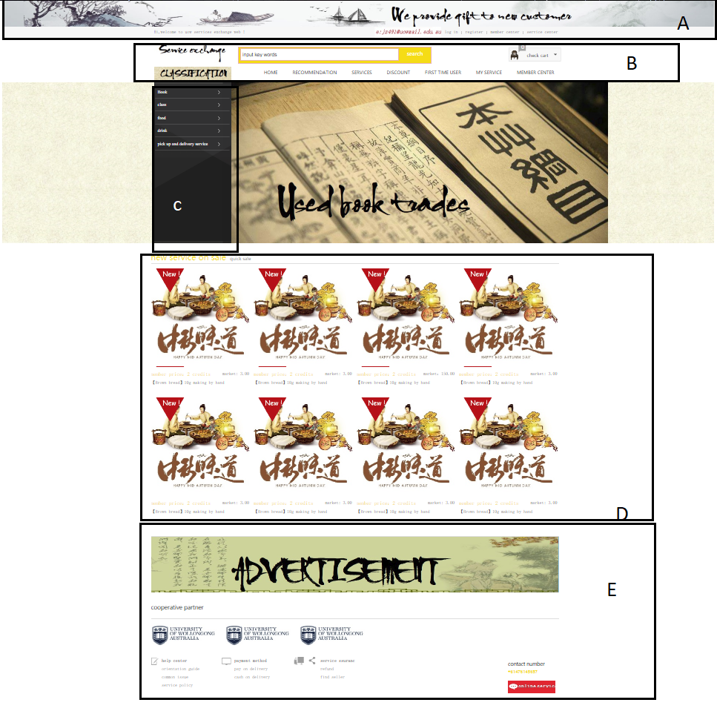

Figure 1 Home Page

## 2.2 Data Flows

The main sources of input for users to use the platform are the keyboard and the mouse. Depending on functionality of device, screen-touch navigation and virtual keyboard can be used to input data and navigate to and from different pages of the web-platform. On launching the Service trading platform, users are navigated to home-page of the platform. This page is the main page from where user can access and navigate to other pages. Similar to contemporary design of any usual design of webpage, the home page consists of five main regions: header section, navigation bar (menu bar), content section, footer section and sidebar. The header section consists of banner of the product, the active user-id and links to login/logoff, register and quick contacts to service centre and member centre. Following header section, there is a navigation bar which consist of search bar where users can type in query for service and service provider. Next to search bar is check cart button where users can view what they have added to their cart. Navigation-bar also consist a menu bar from which users can navigate to different pages such as recommended service page, services page, discounts, first time user, first service and member centre page. On left part of home page is sidebar which consist of classification of services. The sidebar consists of variable elements depending on page to provide accessibility to users depending on the scope of the information being displayed in the current page. All the navigable pages are kept uniform and simple to provide an ease of use to general users.

In figure 1, the black rectangular boxes divides different sections our home page in which section A is header section, B is navigation bar, C is sidebar, D is Content section and E is footer of the home page respectively.

## 2.3 User Access Levels

The platform is owned and hosted by our team and all our team have administrative rights to add new member and in need remove users. All the other users are the general users who can create an account in the platform. With the account created, they can create and sell their services as a provider as well as receive service as a client from other providers. Additionally, they can comment on the services they have used or purchased, communicate/ chat with the service provider.

# GETTING STARTED

As previously explained, as users launch our web-application in any web-browser, users are directed to the home page. From here the users can navigate to different pages as required to perform different available functionalities provided by the system. This section is intended to familiarize users with basic flow of the website and provide an overview of all the elements of the application.

## 3.1 Register to system

At the very beginning user starts with creating an account in the system. For registering, user can press the register button in header section highlighted in following figure.

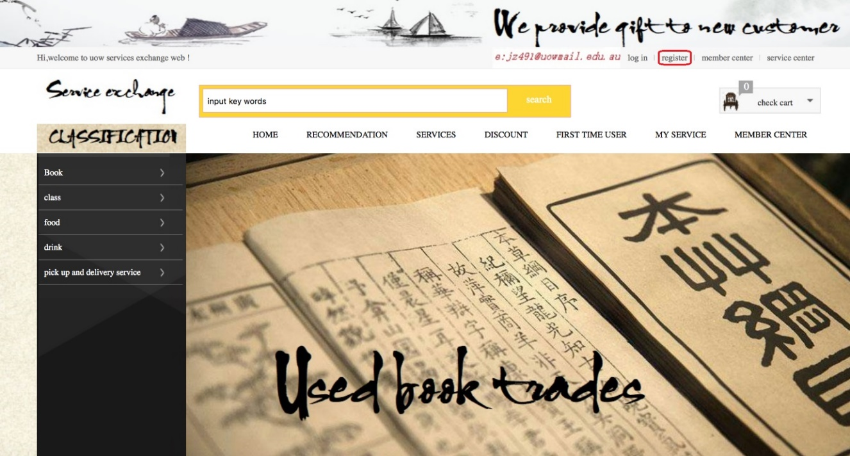

**Steps**:

1. Go to homepage
2. On header section, click on “register”.

Then the user is directed to following page:

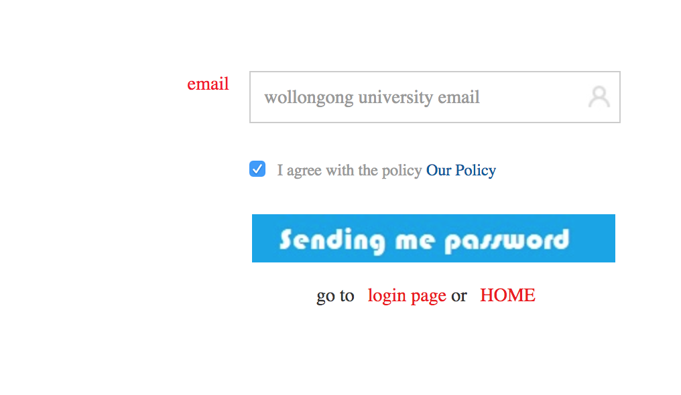

In this page, user needs to put the email address with which s/he is going to create an account in the system. Once the user provides email address and presses the “send me password” button, a system generated password is sent to this email through which user can login to system.

**Steps**:

1. Enter Email address in text field
2. Read policy of using the system
3. Accept policy if you agree
4. Press “send me password” button to receive autogenerated password in given email.

Then, the user is directed to a page where s/he needs to fill in the personal details form. The user is directed to following page:

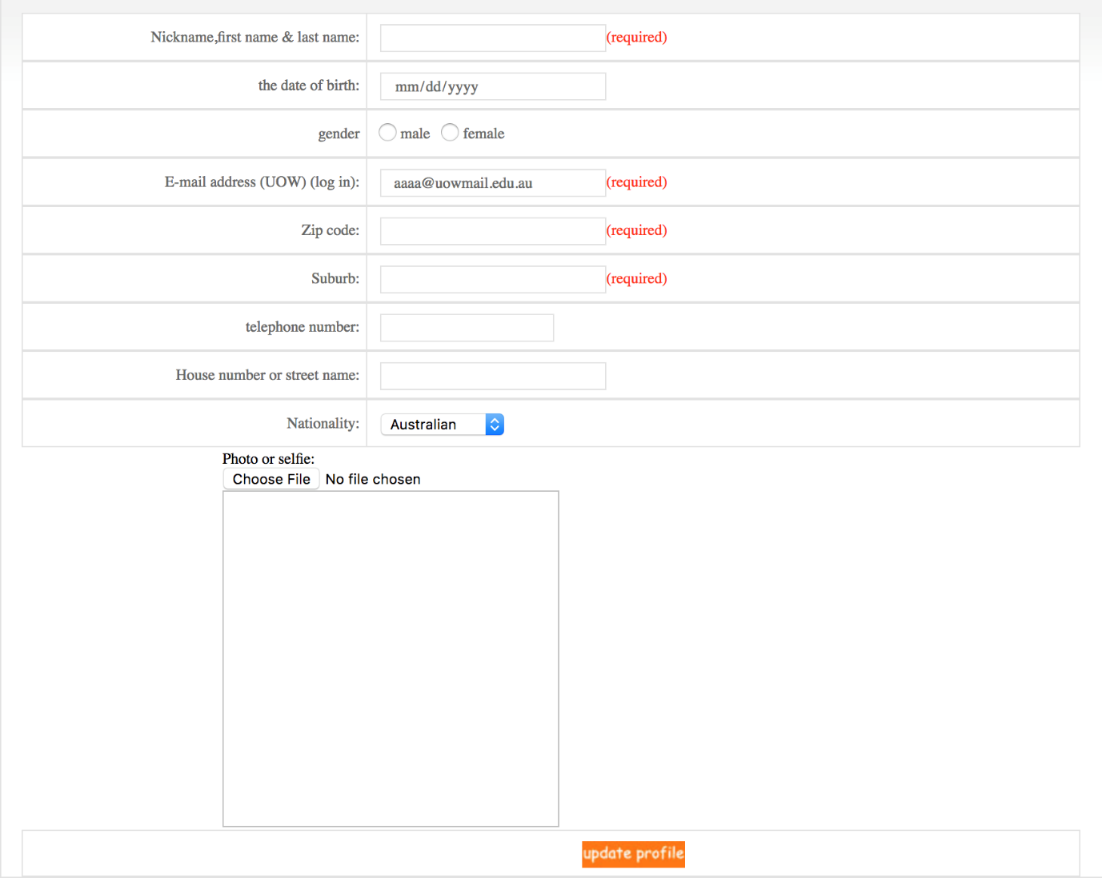

In the form, some of the fields are mandatory fields while other fields can be left empty if the user chooses not to provide empty. The mandatory fields are followed by highlighted red colored text “(required)” as seen in above snapshot. Along with personal details, user can additionally upload a profile picture.

**Steps:**

1. Fill all the respective data fields.
2. Name is all text field.
3. Fill in Date of birth in above format of “mm/dd/yy”.
4. Choose gender and confirm email.
5. Insert valid zip code and suburb of current stay.
6. Fill in valid telephone number. Country code and regional code are not required.
7. Fill in current house number and street address.
8. Select nationality from the drop box.
9. Optionally, upload a recent picture as your profile picture.
10. Click on “Update Profile” button.

A sample of filled form is given below:

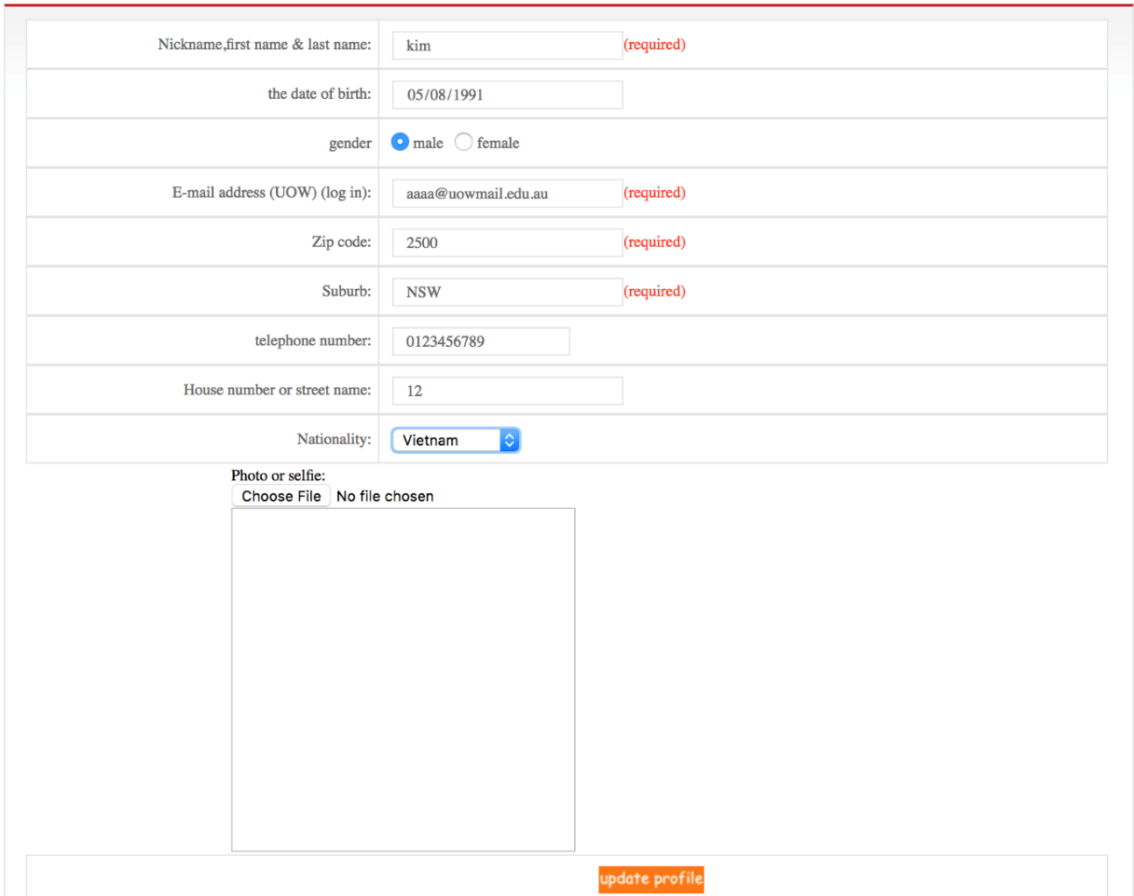

Once user clicks “update profile” button, the details of the user are saved and the account is successfully created.

## 3.2 Logging On

Once the user is registered user can login with user ID which is the email address and password that is generated and sent to email. Using these credentials, a registered user can login to the system. To login, user needs to press login button in the header section of the home page highlighted in the figure below:

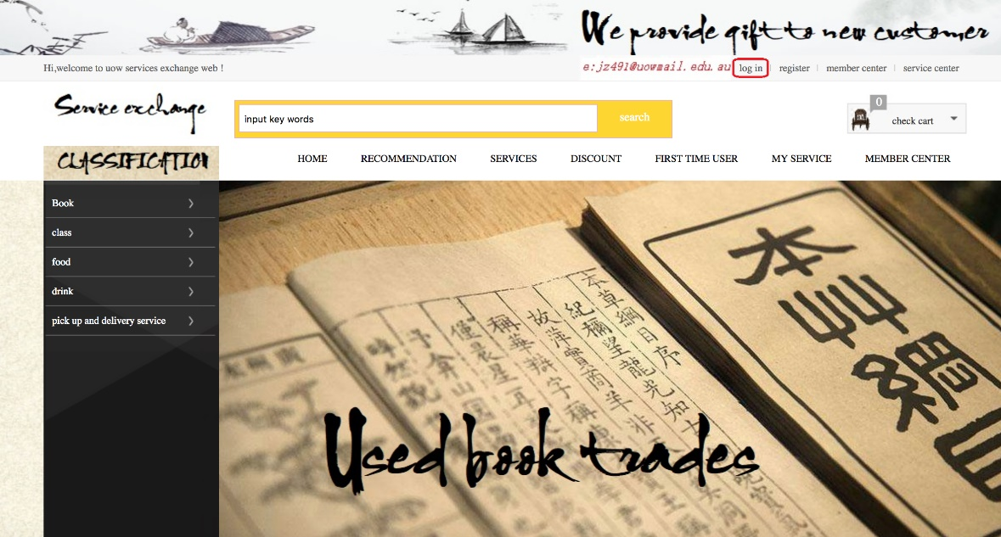

**Steps:**

1. On header section of home page, click on “login”.

The user is directed to following page where user needs to put in the credentials:

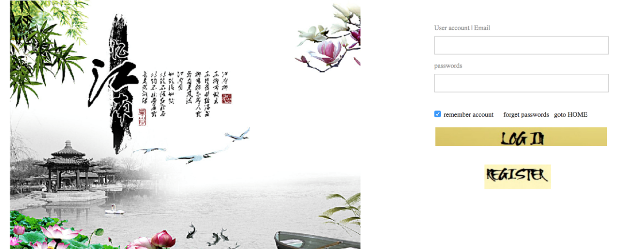

The field user account/email needs to be filled with users emailed and password with users password respectively. Then for ease of further use of the system without having to login time and again, user may choose to remember account. Additionally, in case of forgotten password, user can get back to their account by following steps directed once they click the “forgot password” button. In case, user wants to use webpage anonymously, user may choose to go back to homepage where user can view all services but cannot choose or buy any services unless he logs in. Just in case of new users, who haven’t registered, if they reach through to this page, they can register to system by clicking “register” button. The user then need to follow steps defined in 3.1 section about how to register in the system.

**Steps:**

1. Enter valid username (email id)
2. Enter autogenerated password.
3. Tick “remember account” if you want to save your credentials and save time logging in next time.
4. Press “login” button to login.
5. Press “goto home” to navigate to home button.
6. Press “forgot password” to recover account in case of forgotten password.
7. If no user account has been previously created, click on “register” button to create a new account and get registered in the system.

On successful login, user is directed to home page of user. User can notice their username in the header section of the page once they login. The services in the content section is aimed to display contents as per the preferences and previous choices of the user (yet to be implemented). A sample snapshot of personal homepage is as follows:

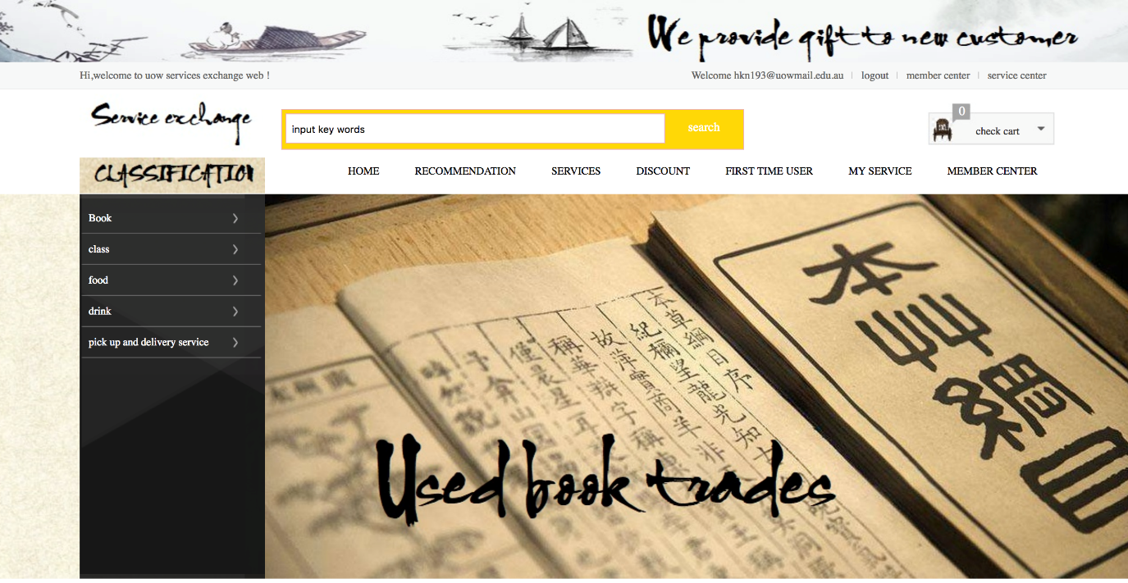

## 3.3 Menu Bar

In home page, the user can see a big search bar followed by “check cart” button with numeric notification. Under these items is a menu bar with seven menu items respectively. User can choose the items to respectively designate to required page and get the corresponding job done. The menu is further explained in following section:

### 3.3.1 Search bar

User can put in the key words to search for any designated services or the service providers they are searching for. Results best matching the search keywords will be displayed on searching for keywords. User can access search functionality through search bar. A sample snippet is given below:

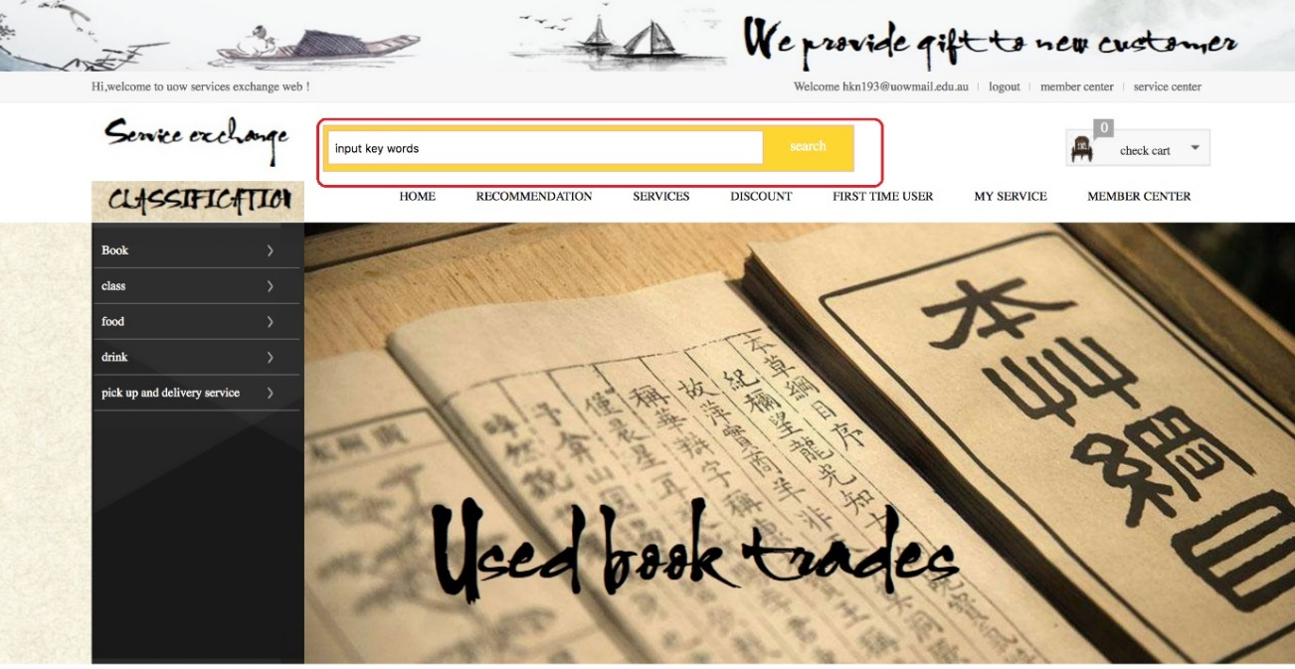

**Steps:**

1. Insert keywords in the search box highlighted in red box.
2. Press search button.

The search results will be then displayed in the content section.

### 3.3.2 Check cart

To view what services has been added to cart so far or the services user has chosen but not finalized, check cart gives numeric notification. The number gives number of services that needs to be checked out. On clicking check cart, the system navigates to following page which displays all the services that needs to be checked out:

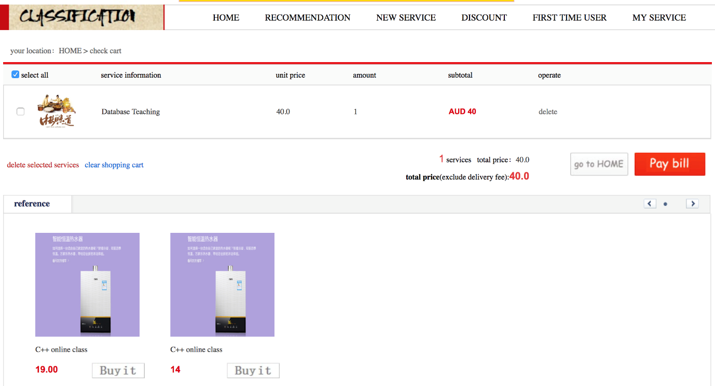

As observable in the above snippet, users can either pay for the service in the cart if they decide to buy the service by clicking on “pay bill” button or else they can delete the selected services by clicking on “delete selected services”. Alternatively, if the user doesn’t like all of the services in the cart, user can simply click “clear shopping cart” in blue text to clear the cart list. User can view the total amount for services as well as subtotal for each service in the description section of the cart. The users, after completing desired operation on the services in cart, can choose to go to home page or any page by clicking on the menu items in the menu bar. For providing and easy way to navigate back to home page, there is a button “go to Home” button as well. On the bottom part of the page you can view recommended advertisement of similar services which users have chosen and added to cart.

**Steps:**

1. On Menu bar, click on “check cart” button.
2. You will be directed to cart list.
3. To purchase services on the cart list, select the purchases.
   1. Click on “pay bill”.
   2. Proceed payment steps.
4. To remove services from cart list:
   1. Select purchases you want to remove and then click “delete selected services”
   2. To delete all the services from list at once, click on “clear shopping cart”.
5. To proceed back to home page select “go to home button” or “home” on the header section.

### 3.3.3 Home page

To direct back to home page from any page, user can press this menu. On pressing this button, user will be navigated back to the home page from any page.

**Steps:**

1. On header section, click “Home”.

### 3.3.4 Recommendation

Based on user’s history of search and purchases new recommendations are made. On clicking “recommendation”, user can view services that are recommended form him/her. The recommendation can be based on historical data of purchases and searches, previous service providers, or the ratings given to services and providers.

**Steps:**

1. On header section, click “recommendation” menu.

Users will be navigated to following page which shows one of the services recommended for the user:

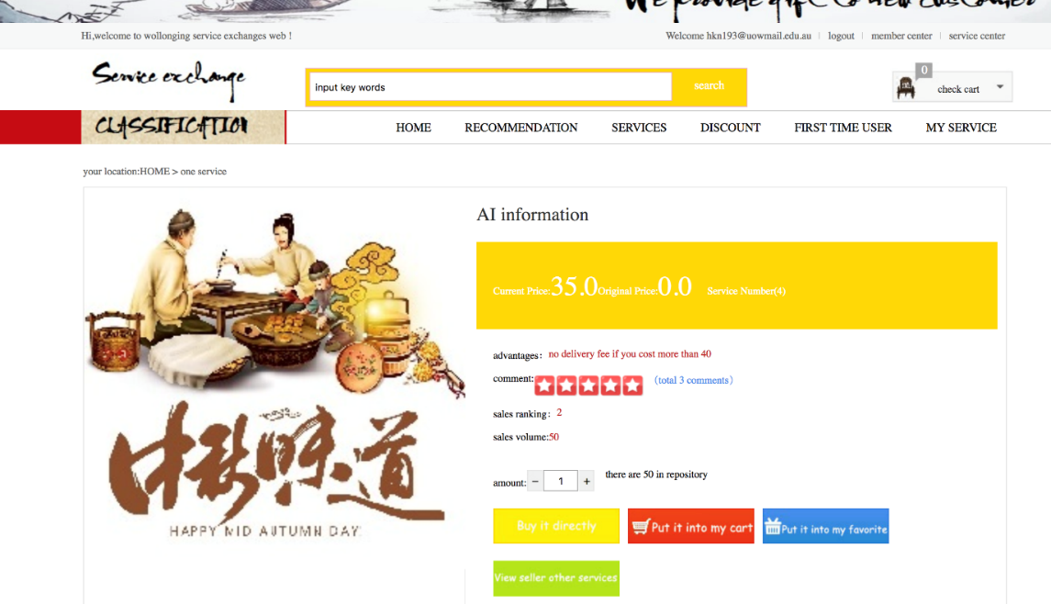

For the recommendation, User can choose to buy it straight clicking “Buy it directly” button or choose to add it in cart by clicking “Put into my cart”. Alternatively, users can put the service to favorites list by clicking “put it into my favorite” so that he/she can view and proceed the service later in time. Users can click on “view seller other services” to check for other services given by the provider. This is useful for users who are satisfied from a provider and seek more of similar or any other services that may be possibly useful for them.

**Steps:**

1. If you like recommendation and instantly want to purchase service, click “Buy it directly” and proceed further transactions.
2. If you like recommendation and want to add service to cart, click “Put into my cart” and proceed.
3. If you like recommendation and want to add service to favorites, click “Put into my favorite” and proceed.
4. If you farther want to see other services provided by the provider, click on “view seller other services”.

### 3.3.5 Services

This is the main page to find the services that are available. Generally, the services appear in some order users can choose and customize.

**Steps:**

1. Click on “Services” menu.

Users are navigated to page whose content if filled with services. On complete development of this project, users will be able to view the services that match their needs the most. For now, the services latest services appear on top on default. User has option to choose the order in which the services will be displayed. The options to choose from to sort the services are according to start date of service, highest number of sales, highest discounts, or according to the price of the service. Users can click one of the “sales”, “new”, Discount” or “price” to select the sorting criteria. On the sidebar, the hottest offer (the most selling services) are displayed. This services page can be navigated by clicking “Services” menu on the menu bar. A sample snapshot of the page is as follows:

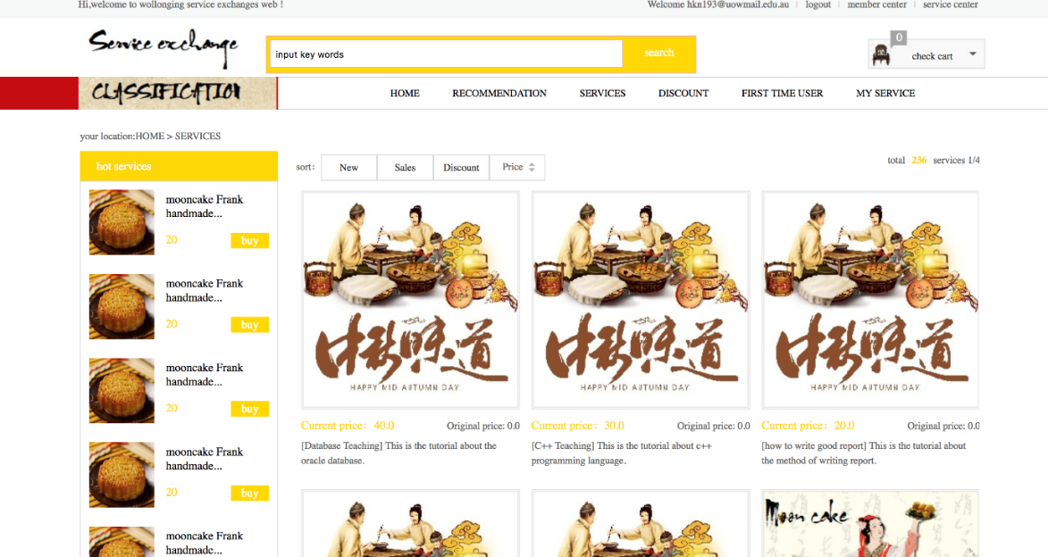

If the user likes any of the services in the content section or in the sidebar, user needs to click that service item to view further detail about that service.

**Steps:**

1. If you like any service, click on the service in the content pane or in the sidebar as well.

After clicking any of the preferred service, following window appears:

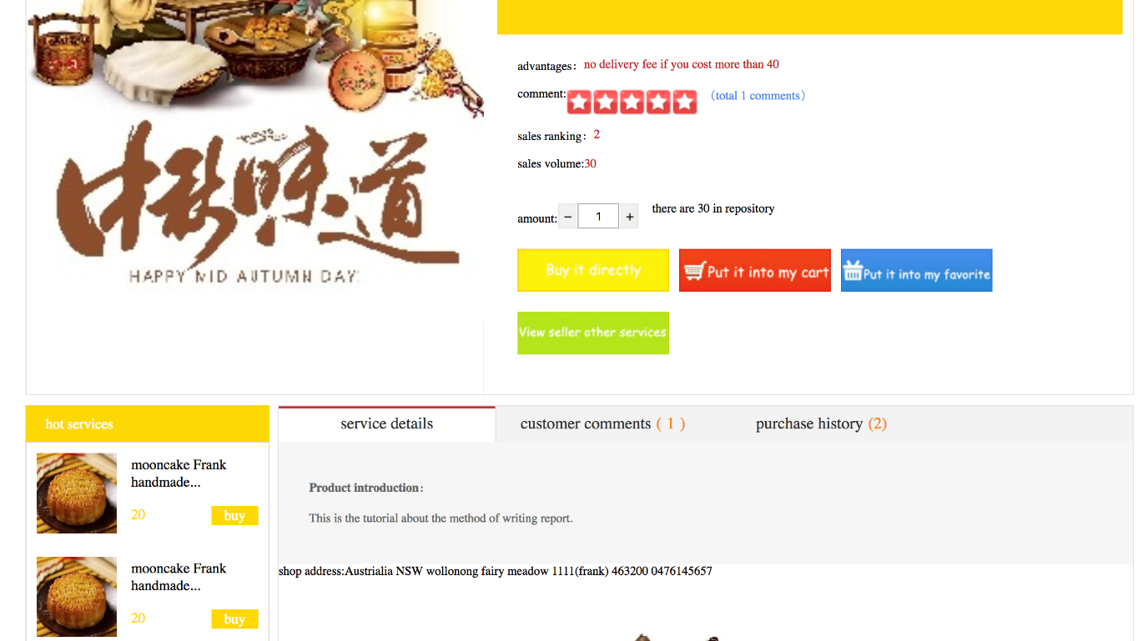

In the opened window, user can view details about the service like the ranking, the available quantity, rating of the service, comments on the service, history of purchases etc. Like case of recommendation menu, users have four options. Once user has chosen the quantity of the service chosen, he can either press “Buy it directly” button to buy directly from user or choose to add it in cart by clicking “Put into my cart”. Alternatively, users can put the service to favorites list by clicking “put it into my favorite” so that he/she can view and proceed the service later in time. Users can click on “view seller other services” to check for other services given by the provider. Following additional steps are available:

**Steps:**

1. Click on “service details” to view details of service product. example snippet:



1. Click “customer comments”. example snippet:

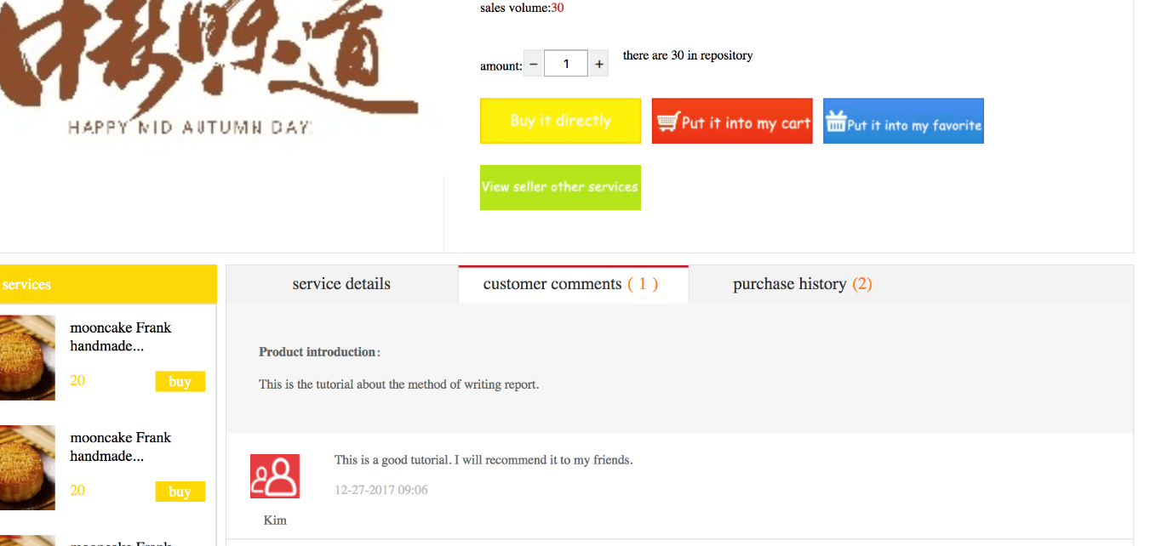

1. The tab is changed from service details tab to customer comments tab and users can view all the comments made by other customers.
2. Click on “purchase history” tab. On clicking this button shows the history of purchase the service i.e., who else has purchased the services prior.
3. If you like the service, you can directly purchase it from provider by clicking “Buy it directly” button. You will be navigated to following checkout functionality page.

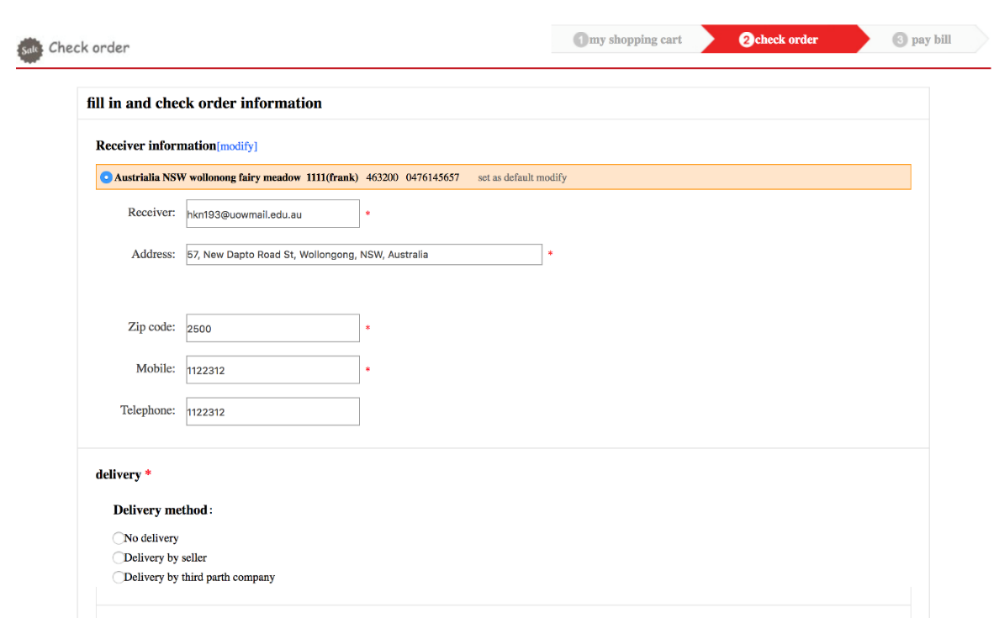

* 1. On default, the personal details stored in system will be auto filled in the text box. Fill in boxes to give alternative address, zip code, mobile and telephone number.
  2. Choose deliver method.
  3. Commit purchase of service by clicking.
  4. You will be navigated to following page:

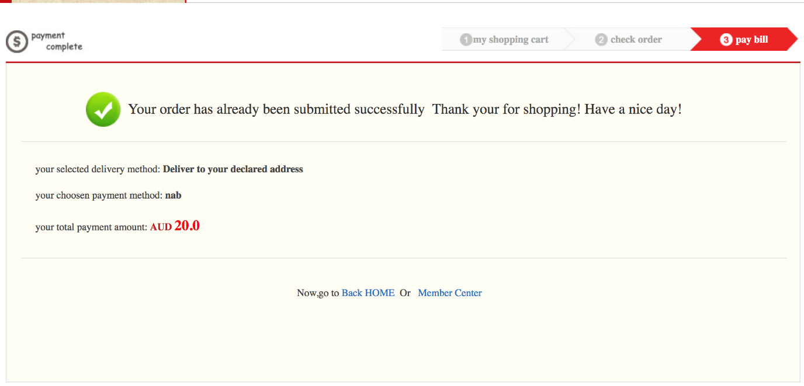

1. Your purchase result will be displayed here along with the cost that may be virtual currency, real currency or exchange service.

### 3.3.6 Discount

Next menu item is “discount” menu clicking on which navigates users to page where users can view all the services that are currently on discount.

**Steps:**

1. Click on “Discount” menu on menu bar.

### 3.3.7 First time user

This is special page for the users who are using the system for the first time. The first time is in a sense that they have not made any purchase of services or posted any of the services in the system. For these users, there are several services that are provided free of cost by the providers with the maim of attracting new users towards them and their services. On clicking “First time user” menu, users can navigate to page where the users can view all the available services that are free for first time users.

**Steps:**

1. Click on “First time users” menu on menu bar.

### 3.3.8 My services

Next menu item is “my services” menu. This menu navigates the system to page where providers can view the status of the services they are providing.

**Steps:**

1. Click on “My services” menu on menu bar.

### 3.3.9 Member Center

Next menu item is “Member center” menu. This menu navigates the system to page where users can view and update their personal details, view the chat history, their comments, purchase records etc. All the available functionalities can easily be accessed from one click operation on the sidebar items. To navigate to member center page:

**Steps:**

1. Click on “Member center” menu on menu bar (alternatively accessible by clicking on “Member center” on header section).
2. To update personal details:
   1. on left sidebar, click on “personal details”. Following page will appear in browser:

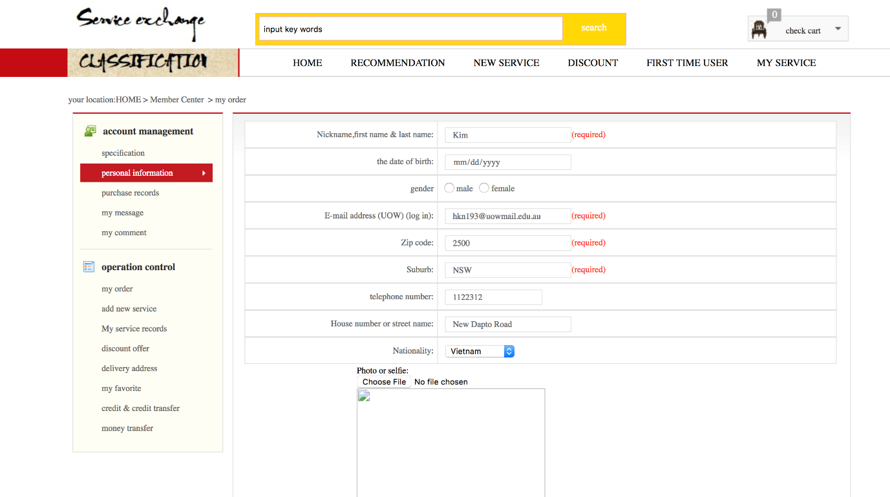

* 1. Update the desired fields that needs to be updated.

1. To view all the purchases made so far, on side bar, click “purchase records”.
2. Following page will appear in the browser where you can view the cost of the purchased service. You can give feedback to the provider publicly by posting comment.

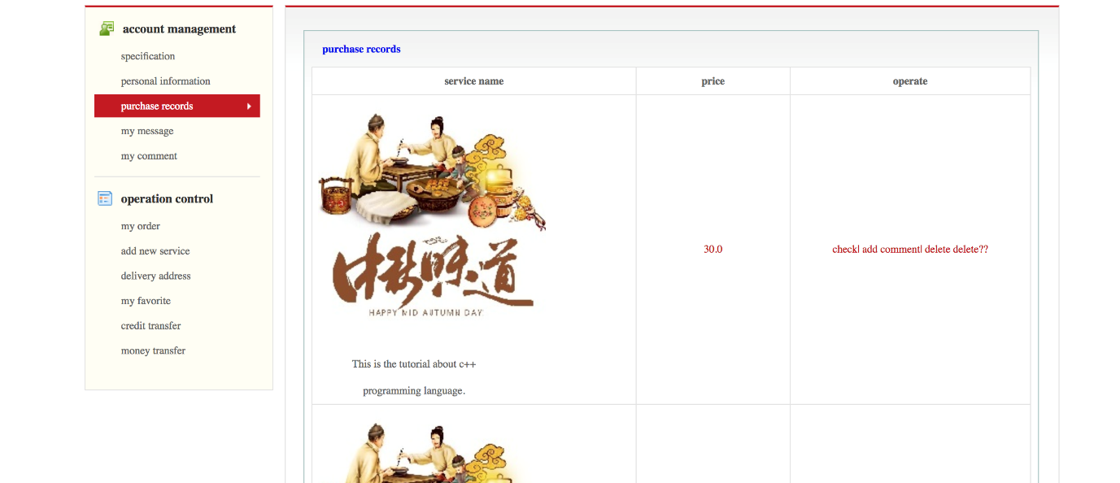

* 1. To comment, click “check/ add comment” in operate column.
  2. Following subpage will be navigated.

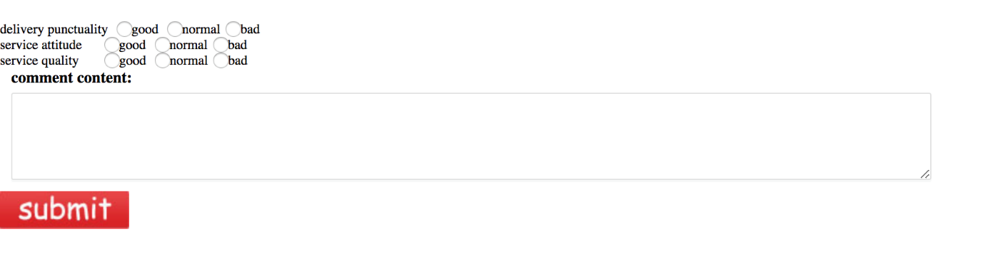

* 1. Choose rating for delivery punctuality, Service attitude and service quality.
  2. If highly satisfied, tick “good”, if satisfied click “normal” else if service was not satisfactory tick on “bad”.
  3. For additional view about service and /or provider, write textual comment in the comment box.
  4. The rating and comments are publicly visible and the user who has made comment have rights over to delete the comments made.
  5. Click on submit button to post comment. You will be directed to confirmation page where you can view if the comment was successfully posted or not.

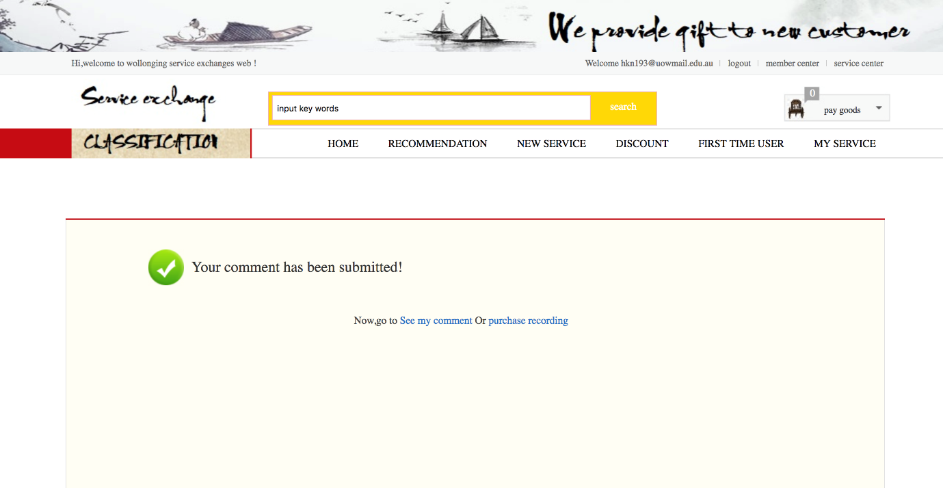

* 1. you can navigate to page where you can view your comment by clicking “See my comment”.
  2. You can navigate back to purchase record page by clicking “Purchse recording”.
  3. You can choose to head back to any other sub menu or menu clicking on the menu on menu bar or side bar.

1. To view message/chat box, click on “my message” on sidebar. You will be navigated to following page:

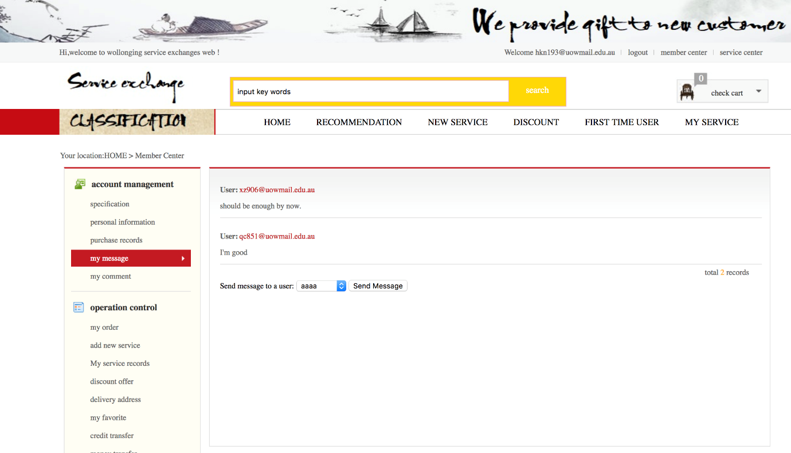

* 1. you can choose to view your communication with other users and or providers by clicking any of the desired message enlisted in the list.
  2. On clicking any of chat, you will be directed to chat box. A snippet of chat box is as follows:

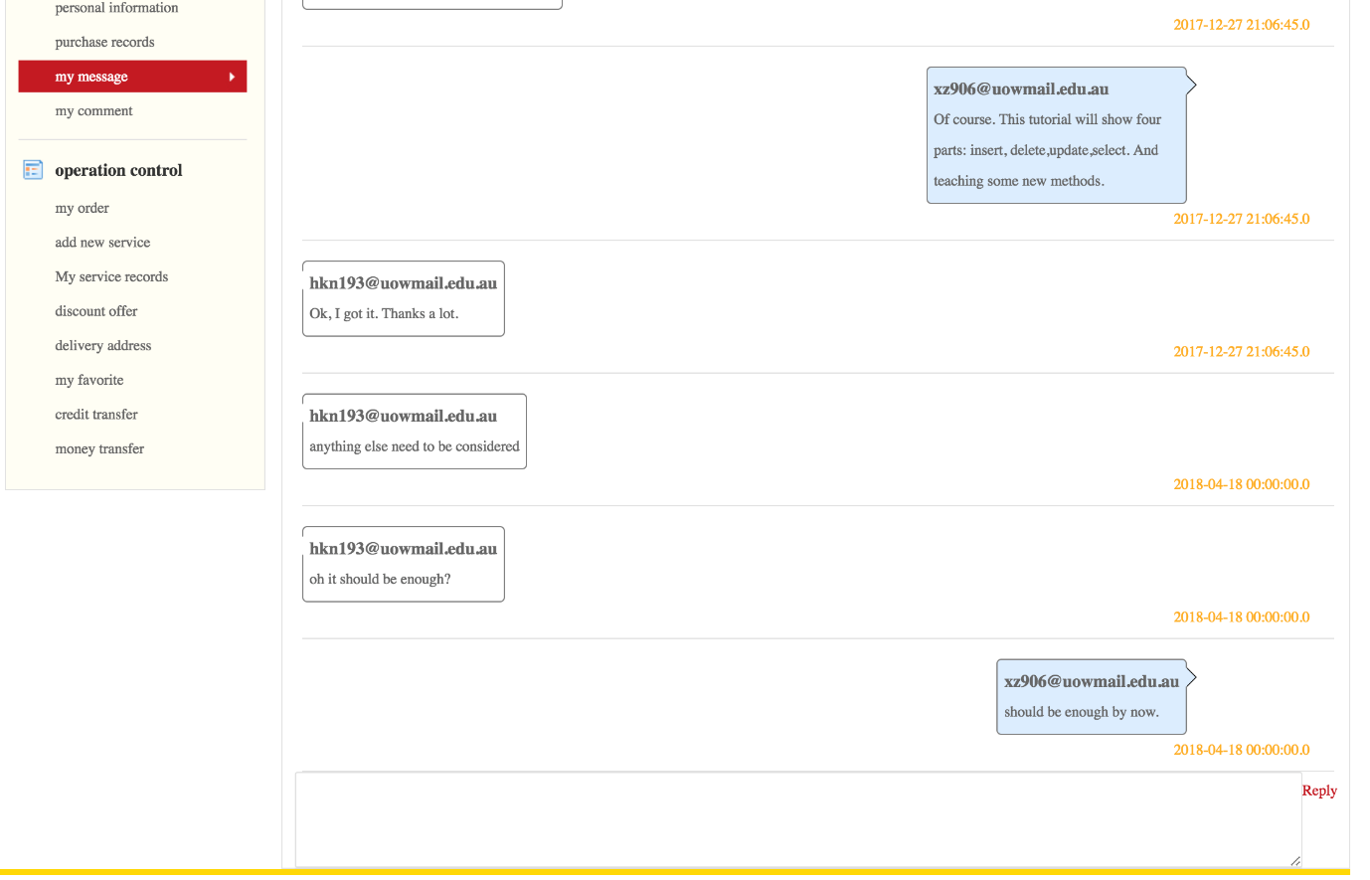

* 1. Alternatively, to send message to new users, select username from dropdown box and click “send message” button. The above conversation pane with no conversation will appear for new conversation.

1. To view all the comments made on the services used or about providers, on sidebar, click “my comment”. You will be directed to following page.

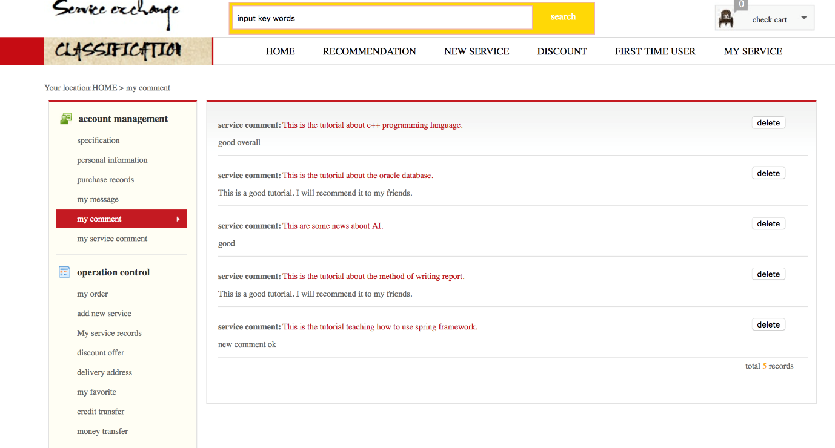

* 1. you can view all the comments made by you so far.
  2. You can choose to delete your comment. Click “delete” button of any comment which is available for every comment on the list.

1. To view all the services you added to favorites, on sidebar, click “my favorite”.

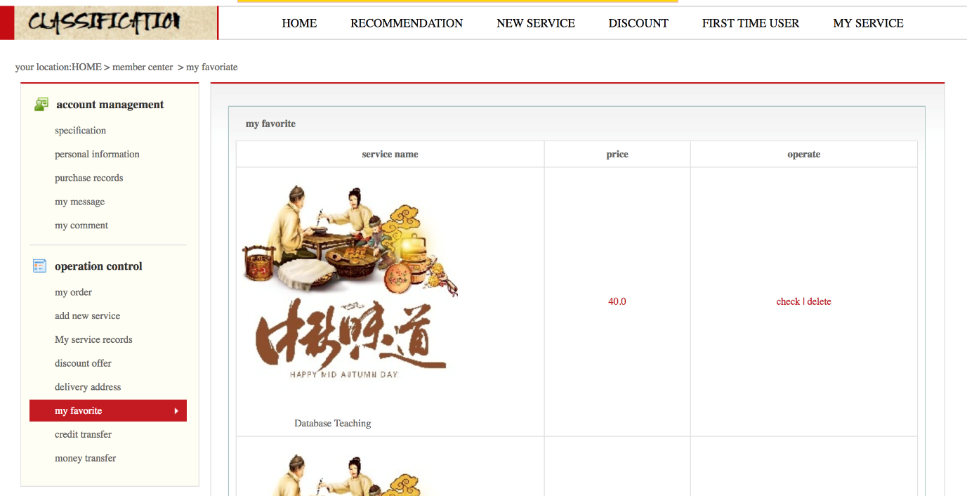

* 1. you can vie service, price and operation available in three columns.
  2. If you choose to check out the service, select check button on “operate” column.
  3. If you don’t like service anymore, you can choose to delete it from list. Select “delete” from operate column.
  4. Following prompt will appear to confirm deletion:

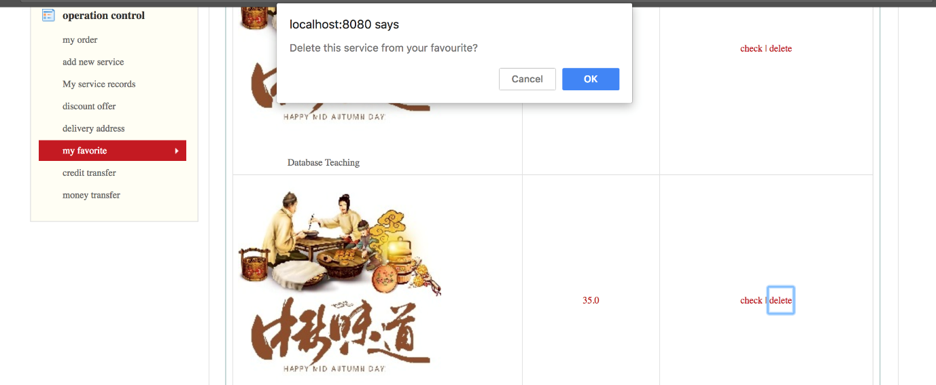

* 1. Click on “ok” to confirm deletion. Else click “cancel” button.

1. To add new service as a provides, on sidebar, click on “add new service”. Following form will be navigated where you can fill in details about the service, its quality, pricing. You could also choose to provide picture/s to give additional information to users:

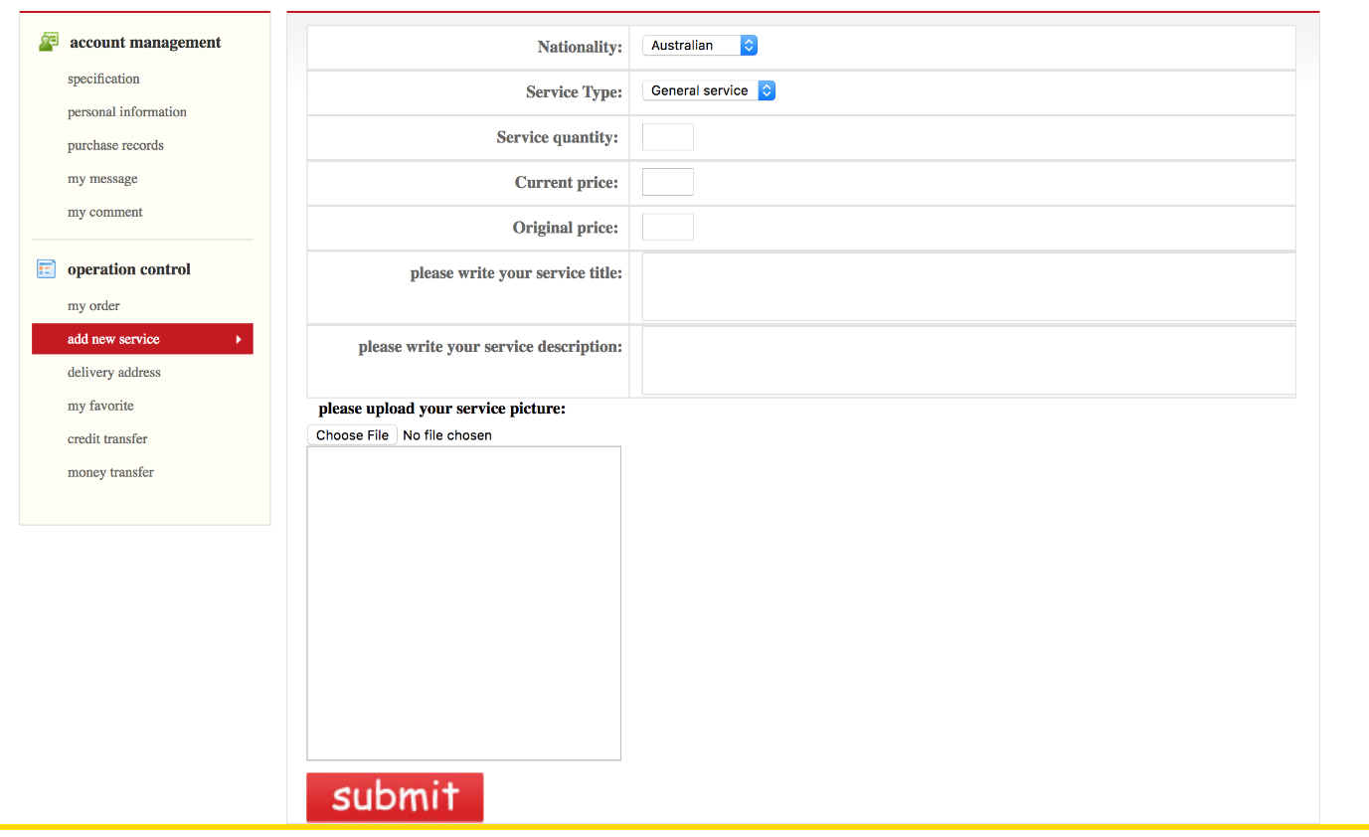

* 1. Fill in Nationality in drop down field.
  2. Fill in type of service in drop down field of service type.
  3. Give the quality of service you expect to provide.
  4. Fill in the price of service in original price.
  5. If you offer discount or give special offers, fill new price in current price.
  6. Give the title to your service in text field.
  7. Give additional description about what the service is about in text field “Please write your service description”.
  8. Upload pictures that will additionally describe your service.
  9. Click on submit button to post the service in the platform and make it visible to general users.

## 3.4 Exit

To exit system, you can choose to exit the system in one of two ways as follows:

### 3.4.1 Logout and exit

To logout from your account you can click on logout button accessible in the header section of any page including home page. To keep your account safe, you are suggested to logout from system that is accessible to other users. You can logout from and exit system as follows:

**Steps:**

1. On header section of any page, you can find “logout” option.
2. Press “logout”.
3. Close the tab in which application is open or the browser itself.

### 3.4.2 Default exit

If you are using a personal trustable system, you can choose not to logout. In case of your personal system and or mobile phone or tablets, you can leave your account logged in to get easy access to the system, updates such as message from clients or providers, comments etc. Using default exit, you don’t need to log in every time you browse the system.

**Steps:**

1. Close the tab in which application is open or the browser itself.

## 3.5 Special instructions for error correction

As getting started to use the system, user creates an account, providing an email address to system during registering process. A system generated password will be sent to the given address. If at any time if user forgets the credentials, user has options to regenerate the password by clicking on “forgot password” button in the login page.

When filling up personal details form, user may unknowingly fill in wrong data like spelling of name, address, or wrong order of phone number or even sometimes suburb and zip code. Additionally, there may be situations when users change his/her address, contacts like mobile number or email address. In these situations, user can navigate to Member center and then to personal details page where s/he can make corrections easily.

In initial phase of use, users may get lost in the branching in sub-branching of individual pages. In any such incidents, users can navigate back to page they are familiar with, which in most cases is home page easily accessible from “Home” button in the Header section. To avoid these situation, at every pages, on top left corner, an indication of path to the current page is provided. For example:

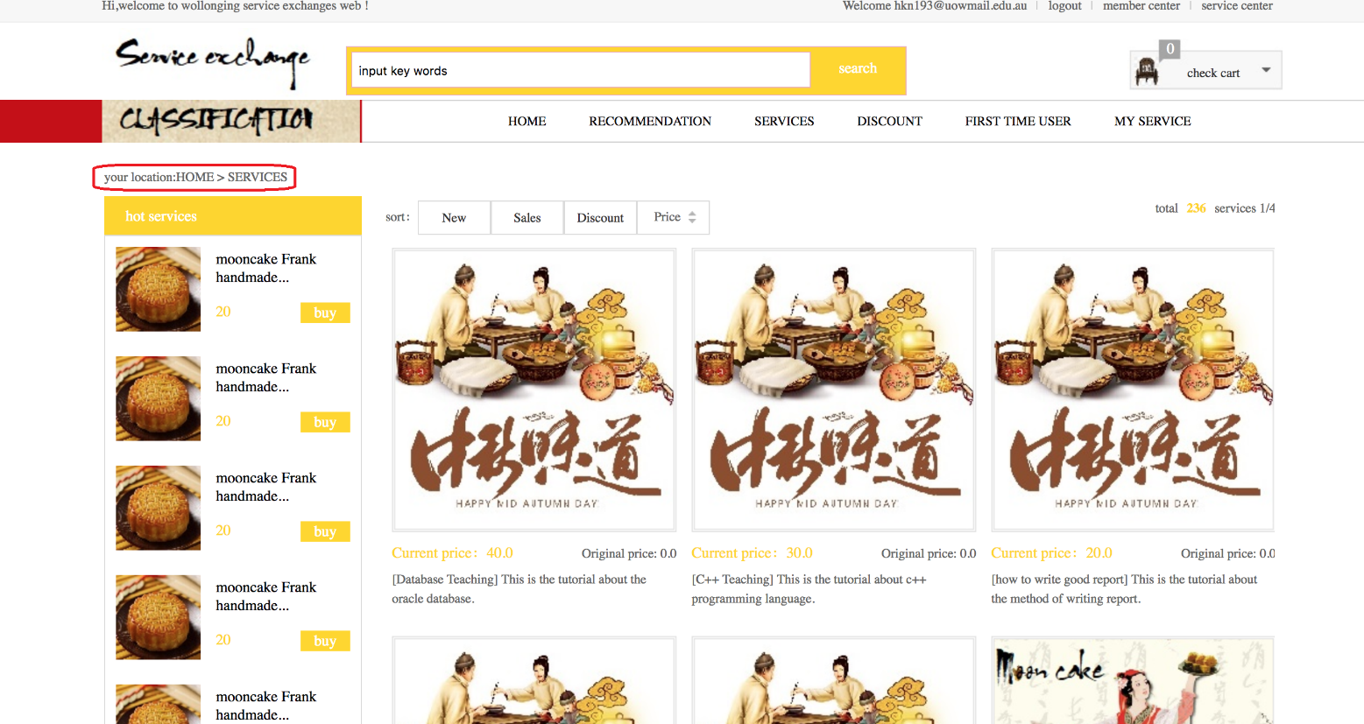

On top left section of the page, you can see “your location” section highlighted by red rectangle where you can see what your current location is.

Apart from navigation, if the users made erroneous comment that needs to be corrected or removed, users can easily do this by navigating to Member center>>my comment and make necessary amendments.

The Services to be posted on the platform are defined in the terms and conditions page which you accept before creating any account or affiliation with this system. Any services that breaches the limitations or tends to harm any user will be immediately removed. Any service that receives three or more complaints from users will be put on hold for investigation. The service will then not be available on the platform until the investigation is completed or written clarification is presented to the administrative department of the system. The contact personals are clearly defined, and their contact email is provided at the beginning of this document. Any changes to Terms and conditions or any documentations will be notified to each user via email address registered on the system.